**No Deposit and Variance checking**

Step 1: Open the document which we need to check no deposit and variance

Ex: Pending Deposit Apr 2017 Dallas.xlsx

Step 2: Check the workbook has hide sheet or not like

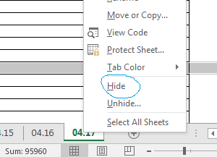

It shows hided tabs. If 1 sheet is hide we need to change the coding

Step 3: Launch VBA editor by Pressing Alt+F11 then select module from left project panel and check it has function name deposit()

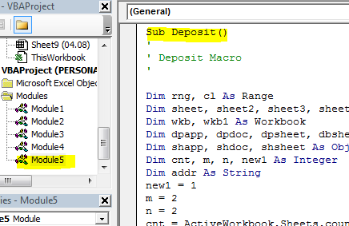

Step 4: if 1 sheet is hided unhide the sheet and change the code like

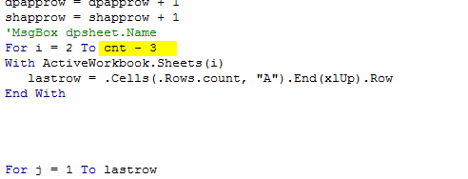

If 2 sheet is hided FOR i=2 to cnt-4 like wise

Step 5: create two sheets and the end of all sheets

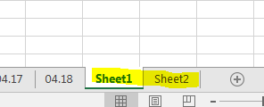

Step 6: check No deposit.xlsx book and variance.xlsx book available in

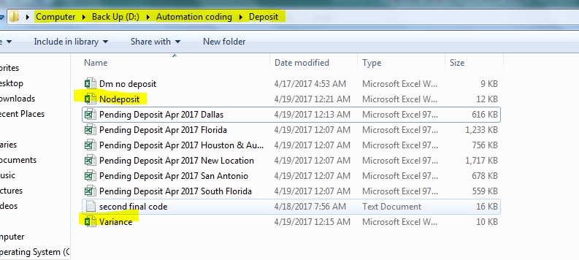

Step 7: Open Nodeposit.xlsx and clear all the contents in sheet1 and sheet2 and open variance.xlsx and clear sheet1

Step 8: close All excel books except Ex: Pending Deposit Apr 2017 Dallas.xlsx

Step 9: Run the deposit() module and get the desired output in

* Sheet1 , Sheet2 in Pending Deposit Apr 2017 Dallas.xlsx
* Book1 and Book2 DM wise filtered output
* Nodeposit.xlsx and variance.xlsx for all market results.